SQL Queries

- select sum(total_price)As Total_Revenue from pizza_sales
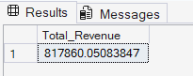

- select sum(total_price)/count(distinct order_id)As Avg_order_value from pizza_sales
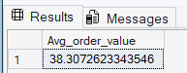
- select sum(quantity) as Total_pizza_sold from pizza_sales
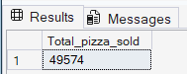
- select count(distinct order_id) as Total_Orders from pizza_sales
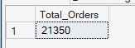
- select cast(cast(sum(quantity) as decimal(10,2))/
cast(count(distinct order_id) as decimal(10,2)) as decimal(10,2)) as avg_pizza_per_order from pizza_sales
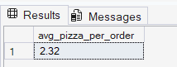

- select datepart(hour, order_time) as order_hour,
sum(quantity) as total_pizza_sold from pizza_sales group by datepart(hour, order_time) order by datepart(hour, order_time)
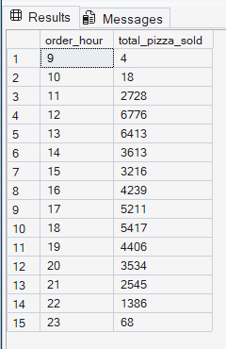

- select DATEPART(iso_week,order_date) as week_num, year(order_date) as year,count(distinct order_id) as total_orders from pizza_sales
group by DATEPART(iso_week,order_date),year(order_date)
order by DATEPART(iso_week,order_date),year(order_date)

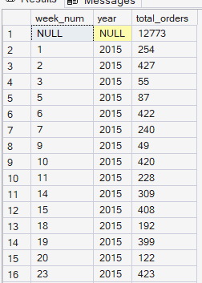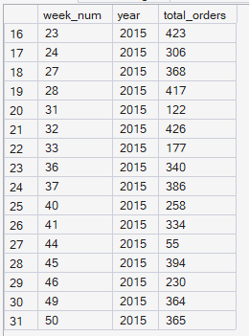

- select pizza_category,sum(total_price) as total_sales, sum(total_price)*100 / (select sum(total_price) from pizza_sales where month(order_date)=1)
as PCT from pizza_sales where month(order_date)=1 group by pizza_category
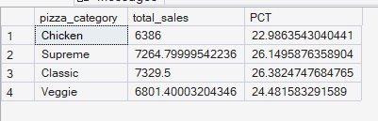

- select pizza_size,cast(sum(total_price) as decimal(10,2))as total_sales, cast(sum(total_price)*100 / (select sum(total_price) from pizza_sales where datepart(quarter,order_date)=1 ) as decimal(10,2)) as PCT
from pizza_sales
where datepart(quarter,order_date)=1
group by pizza_size
order by PCT
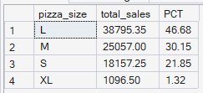
Top 5:
- select top 5 pizza_name,cast(sum(total_price) as decimal(10,2)) as total_sales from pizza_sales
group by pizza_name order by total_Sales desc

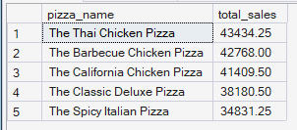

Bottom 5:
select top 5 pizza_name,cast(sum(total_price) as decimal(10,2)) as total_sales from pizza_sales
group by pizza_name order by total_Sales asc

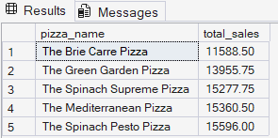

- select top 5 pizza_name,cast(count(distinct order_id) as decimal(10,2)) as total_orders from pizza_sales
group by pizza_name order by total_orders desc
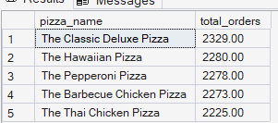

- select top 5 pizza_name, sum(quantity ) as total_pizzas_sold from pizza_sales
where month(order_date) = 8
group by pizza_name order by sum(quantity )

